The proposed web application system broadly involves two design aspects. We discuss the user interface design aspect in this section.

***USER INTERFACE DESIGN***

We first provide a list of indicative webpages that will comprise the proposed system:

* **Welcome Page**
* **Registration Page**
* **Administrator Page**
* **Quarterly Sales Details Page**
* **Add Product Page**
* **Delete Product Page**
* **Add Category Page**
* **Delete Category Page**
* **Discount Offers Page**
* **Add Card Page**
* **Delete Card Page**
* **Modify Card Page**
* **Issues Page**
* **Search Page**
* **MyAccount Page**
* **MyCart Page**
* **MyPurchase History**
* **MyFeedback&Rating**
* **MyComplaints**
* **MySubscription**
* **Personal Information Settings**
* **Product Listing Page**
* **Product Item Page**
* **Feedback page**
* **Complaint page**
* **Manage Card page**

**FLOW DIAGRAM OF USER INTERFACE:**

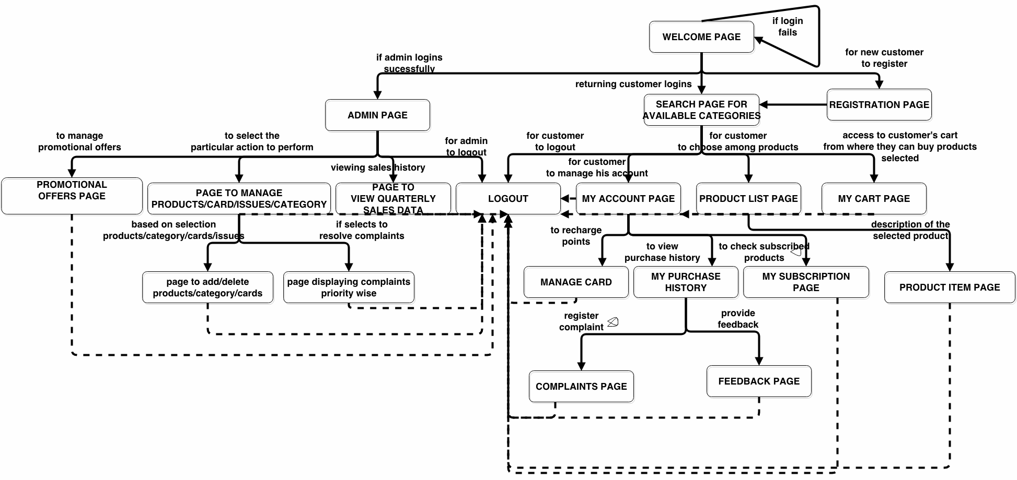

The ensuing subsection describes in detail the features & functionalities to be offered by each of webpages:

The system will be implemented for the following users:

* CUSTOMERS
* ADMINISTRATORS

**Welcome Page**

User Login: This is for the returning users who already have an account with the online store. This feature is used to login to the particular account in order to buy products, add products to cart, provide feedback on a particular product etc. A successful login directs the user to the Search Page.

Administrator Login: This feature is used by the administrator of the system to login to the system in order to view inventory, add or delete products etc. A successful login directs the user to the Administrator Page.

Forgot Password: This feature will help an existing user to retrieve the password for his account, in case he does not remember it or has lost it. The user will be notified about his password by an email sent to his mail id.

New User Registration: A new user will have to register in order to have an account with the application. He will need to fill out a form which will contain his basic information and he will also create a username and password combination for his account. This combination will be required each time he logs in to the system. These data will be stored in the database, to be used whenever necessary during transaction etc.

The input to welcome page decides the activity flow in terms of webpage links. The possible activity flow of an end-user is described in the following sections.

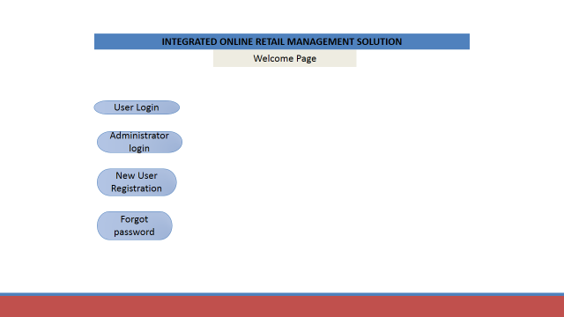

**Registration Page**

A form will be provided to the new user in this page which will have to be filled out by him. The fields in this page will include:

**First Name** – The first name of the user.

**Last Name** – The last name of the user.

**Address** – The current address of the user.

**Phone #** - The current phone number of the user.

**Email** – The email id of the user.

**Card type** (User can select from a drop-down menu which card type he wants and accordingly he will be allotted some points. Since we are not dealing with bank transaction part in our project, we will assign points to users which will be used to replace money.

**Username** – A username, to be selected by the user, which will be used to login to the system.

**Password** – A password, to be selected by the user, which will be used to login to the system.

When the user, after filling out all the fields, submits the form, the values will be verified according to constraints set on the database. The user may be required to correct some field values accordingly.

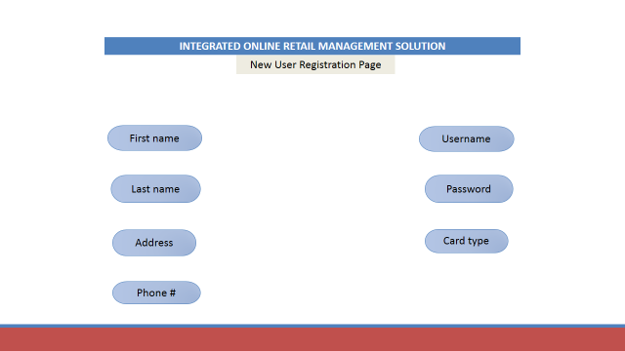

**Administrator Page**

**View Quarterly Sales Details** – This feature will allow the administrator to view the quarterly sales figure for the store on Quarterly Sales Details Page and this can be modified based on geographic locations, trends during a particular season etc.

**Add/Delete Product** – This will direct the administrator to the Add Product Page from where he can add a new product to an existing category. A product can also be deleted from a particular category on the Delete Product Page. It has to be ensured that all other details related to this product are also be deleted.

**Add/Delete Category** – This will direct the administrator to the Add Category Page from where he can add a new category in to the database and also add at least one product belonging to this newly added category. A category can be deleted from the store using the Delete Category Page and all the products belonging to that category will also be deleted thereby.

**Provide Promotional Offers** – Discounts and other offers can be provided to users during a festive season, on specific days or simply for the promotion of a product. This can be taken care of by the administrator from the Discount Offers Page.

**Add/Delete Card** – The administrator will be directed to either the Add Card Page, Delete Card Page or Modify Card Page from where cards and their corresponding points can be added, deleted or modified on need and demand basis into the database respectively.

**Address Issues** – This feature enables the administrator to view all the complaints logged by different users in Issues page and address them on priority basis.

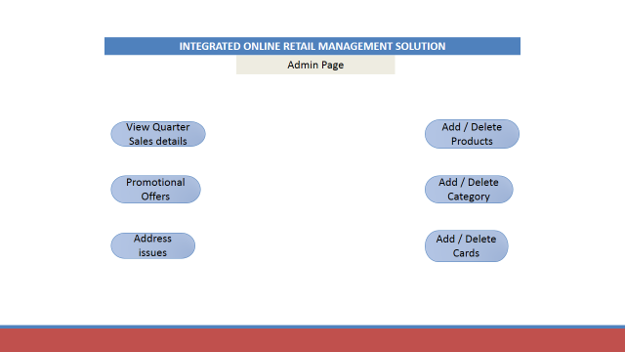

**Quarterly Sales Details Page**

This page displays the quarterly sales figure for the store and this data can be filtered out on the basis of geographic location of customers, a specific product or a specific category. The administrator can select from a drop-down, the filter condition based on which data is to be displayed.

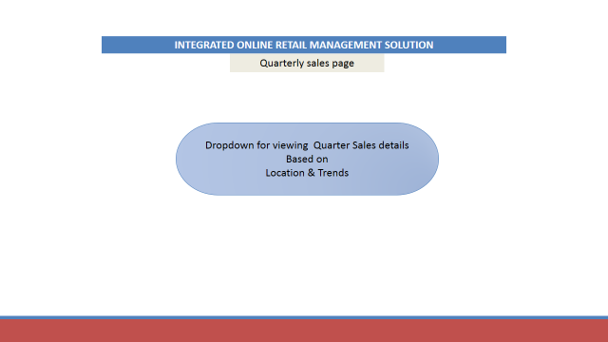

**Add Product Page**

The administrator will be provided with a form containing the following fields where he can enter the new product information to be added to the database:

**Product Name** – Name of new product to be added.

**Category** – Category to which the new product belongs.

**Price** – Price of the new product.

**Number In Inventory** – Number of items of this particular product that are available in inventory.

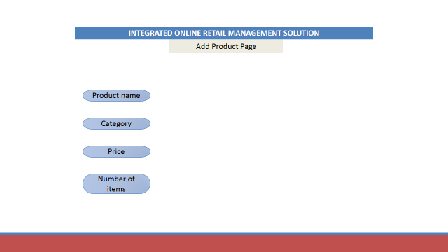

**Delete Product Page**

In case of deletion of an existing product, only the Product Name and Category are required to be provided.

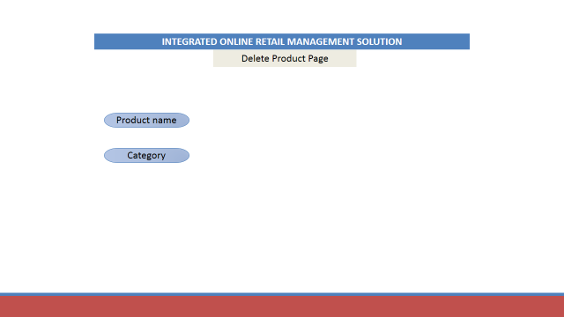

**Add Category Page**

The administrator can add a new category and the first product of this category along with it using the following form:

**Category** – New category to be added.

**Product Name** – Name of new product to be added.

**Price** – Price of the new product.

**Number In Inventory** – Number of items of this particular product that are available in inventory.

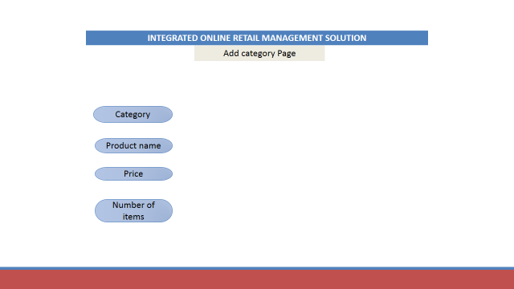

**Delete Category Page**

In case of deletion of an existing category, only the Category name is required to be provided.

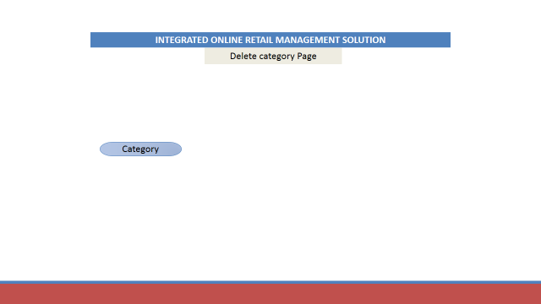

**Discount Offers Page**

Discounts can be provided to users using the following fields:

**Product Name** – Name of the product for which discount will be provided.

**Category** – Category of the product.

**Price After Discount** – New price of the product after discount is offered to the customer.

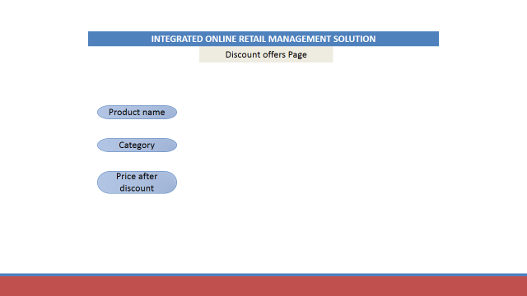

**Add Card Page**

A new type of card along with its corresponding points can be added to the database using the following fields in this page:

**Card Type** – The new card type to be added.

**Points** – Points allotted to the new card type.

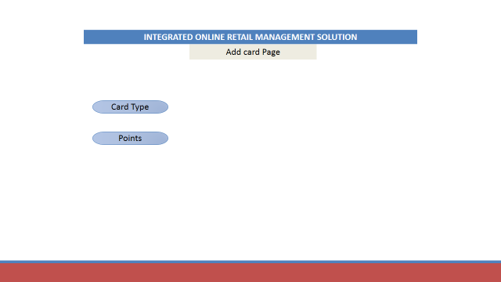

**Delete Card Page**

An existing type of card can be deleted by providing the card type.

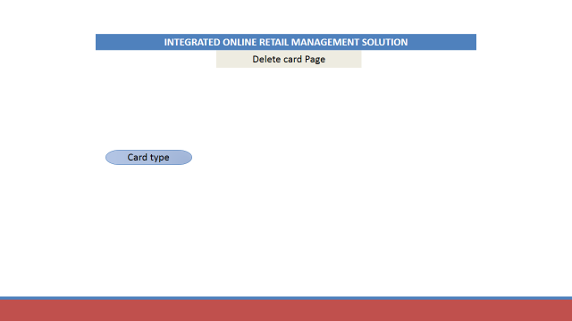

**Modify Card Page**

The points allotted to an existing type of card can be modified using the below fields:

**Card Type** – The card type from the existing ones.

**Points** – Points newly allotted to this card type.

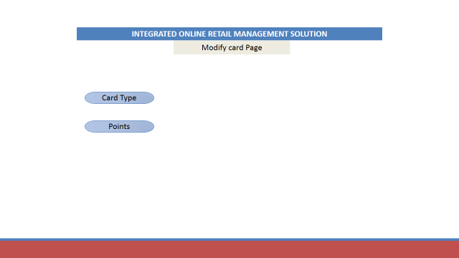

**Issues Page**

A list of current issues logged by users is displayed to the administrator which he can address to by taking the necessary action.

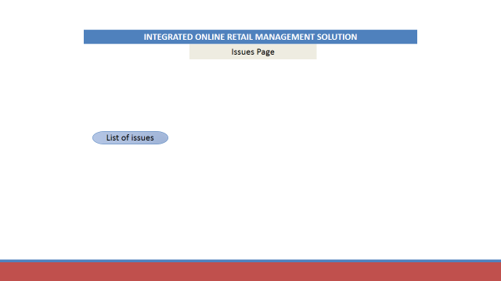

**Search Page**

**Display Categories** – All the product categories will be displayed on this page. A user, on selection of a particular category, will be directed to the Product Page which will have a listing of all products belonging to the category.

**MyAccount** – This feature allows a user to go to his account from where he can change his existing password, register a complaint or provide a feedback on a particular product which he has bought.

**MyCart** – A user can access his / her shopping cart which will display to him all products selected by him but not yet bought.

**Recommendations** – The system will provide recommendations to users based on other products selected by him and also about products which other users of similar interests have viewed/bought.

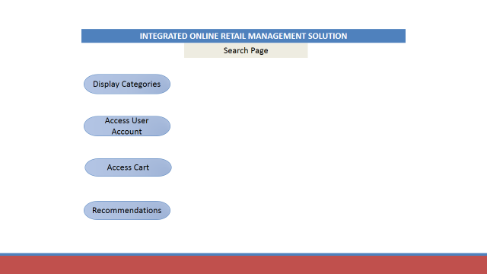

**MyCart Page**

**Remove Product** – User can view the products in his/ her cart and can remove a particular product at any time.

**Buy The Product** – The user can buy the products in his cart. Once a user buys a certain product, details with respect to this purchase are visible in the “My Purchase History” of MyAccount Page.

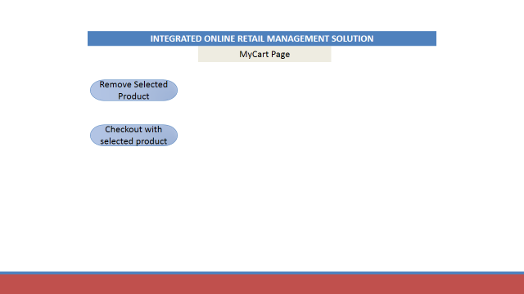

**MyAccount Page**

The MyAccount page is accessible from any webpage in the application.

Every registered user shall have a personal account page which will contain the following information pertaining to the particular user.

**MyPurchase History Page**

Linked from MyAccount Page. The purchase history of the customer is displayed here. It includes information such as date_of_purchase, productID, ProductName, price, quantity.

**MyCart**

Linked from MyAccount Page. The present status of cart which include information like productID, ProductName, price, quantity is displayed.

**MyFeedback & Rating**

Linked from MyPurchase History page. The user is able to view the listing of feedback & rating he/she has provided in past. For Data includes date, productID, ProductName, FeedbackID, Feedback_Description, rating.

**My Complaints**

Linked from MyPurchase History page. The user is able to view the listing of his complaints. Data includes date, productID, ProductName, Complaint_Description, Complaint_Priority, Resolution_Status.

**MySubscription**

Linked from MyAccount page. The user is able to view the list of subscribed products. Data includes productID, ProductName, price, Inventory Status.

**Personal Information Settings**

The user is able to update/add personal information such as Address, Phone #, Card type, Password which had been provided during registration by the user.

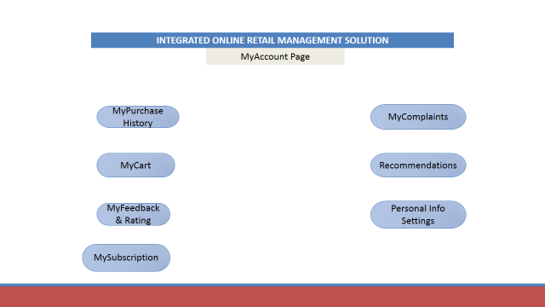

**PRODUCT LISTING PAGE**

This page is linked from the search page. Each category listed in the search page will have a corresponding product page containing a listing of all products belonging to a particular category.

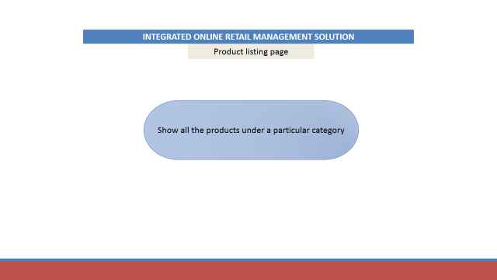

**PRODUCT ITEM PAGE(s)**

These pages are linked from the corresponding product listing page. The product ID page will contain exhaustive details about the product. Data include product image,product ID, product name, Product price, inventory status for the product, rating of the product by other users, feedback on the product by other users, Popularity quotient of the product based on sales figure, customer satisfaction, what other customers are currently viewing, suggestions of accessory parts

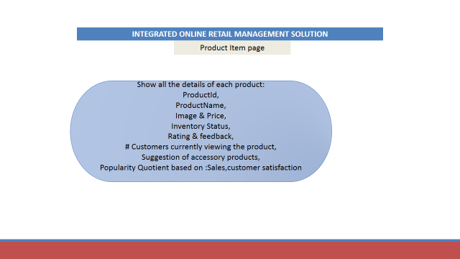

**FEEDBACK PAGE**

The feedback page form is linked from the MyPurchase_History section of MyAccount page. A user is able to provide his feedback on a particular product already purchased. The form will accept the feedback description from the user pertaining to a particular product.

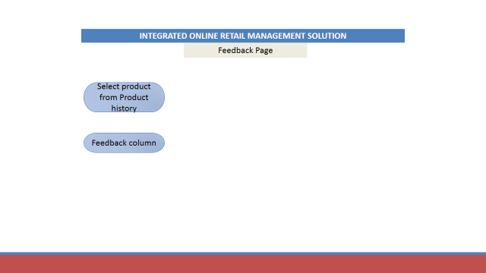

**COMPLAINT PAGE**

The complaint page form is linked from the My_Purchase_History section of MyAccount page. A user is able to provide his complaint on a particular product already purchased. The form will accept the complaint description from the user pertaining to a particular product.

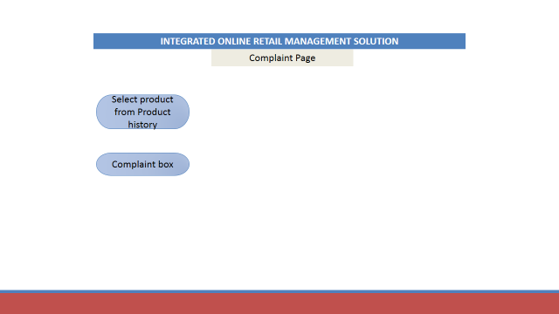

**MANAGE CARD PAGE**

This page is linked from any page in the system. A user is able to recharge his points card if remaining point balance is less than 100. The page will have option for the user to select card type.

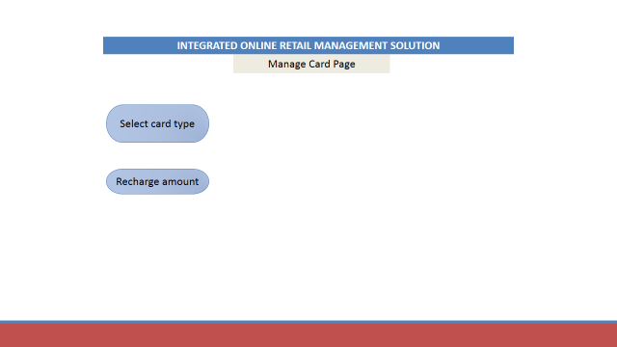

**CONCEPTUAL DATABSE DESIGN**

Conceptual database design which includes Entity Relationship model where important entity sets, relationship sets along with the cardinalities and relevant attributes are illustrated below.

**ER diagram description:**

* The system is accessible to two types of users identified by userId, usertype. Any user will have emailId, password, first name, last name, address, phone number. A user may have multiple phone numbers, and address is composed of street number, city, state, zipcode.
* Any administrator or customer is a user of the system.
* An admin can manage the one or more product categories hosted by the system. An admin can also manage cards offered by the system and the points allocated to each card type. He is responsible to address complaints registered by customers about any particular product on a priority basis.
* Each category is uniquely identified by categoryId and category name. A category consists of several products. Every product has a unique productId with other attributes like product name, product description, price, stock left.
* The system offers different types of cards where each card is associated with definite number of points.
* Any customer is able to view/purchase a product by using his card points. He may purchase one or more quantities of a particular product. A customer can subscribe for the product to receive updates and can also manage products in his cart. The system allows the customer to provide feedback /register complaints with priority on items previously purchased.

**ER DIAGRAM FOR Step2Shopify @ GatorNation**

